Q- Bank
User’s Manual

Self-Administered Population & Establishment Questionnaires

Version 1.7
8/15/08

The Q-Bank database is an interagency activity, supported by the U.S. Bureau of the Census, the National Science Foundation, the National Cancer Institute of the National Institutes of Health, and the Bureau of Labor Statistics. Q-Bank is managed and hosted by the National Center for Health Statistics (NCHS).
Any questions regarding the preparation and submission of reports to Q-Bank should be directed to the Q-Bank administrator at qbank@cdc.gov.

Table of Contents

Introduction: Q-Bank Submission Guidelines …………………...………………….. |  | 5
Coding Fields
Part I: Questionnaire Level Fields and Categories
1. | Survey Title………………………………………………………………………. | 8
2. | Survey Year …...………………………………………………………………... | 9
3. | Testing Agency …………………………..……………………………………... | 10
4. | Test Date ………………………………………………………………………... | 11
5. | Principal Investigator ...……………………………………………………....... | 12
6. | Sponsor ………………………………………………………………………….. | 13
7. | Universe ………………………………………………………………............... | 14
8. | Evaluation Type……………………………………………………………........ | 15
9. | Documentation…………………………………………………………………... | 16
10. | Pre-testing Mode .………………………………………………………….…… | 17
11. | Field Mode………………………………………………………….................... | 18
12. | Global Instructions………………………………………………………........... | 19
Part II: Question Level Fields and Categories
13. | Introductory Text (Overall Question or Instructions)…………………………  Core Question……………………………………………………….................. | 21
14. |  | 22
15. | Objects – Matrix only………………………………………………………........ | 23
16. | Instructions Following Core Question………………………………………… | 24
17. | Response Option Text………………………………………………………….. | 25
18. | Instructions Following Response Options…………………….……………… | 26
19. | Information Type……………………………………………………….............. | 27
20. | Response Category………………………………………………………......... | 31
21. | Target Population………………………………………………………............. | 33
22. | Sequence Number………………………………………………………........... | 34
23. | Response Error – Population Surveys……………………………………….. | 37
24. | Response Error – Establishment Surveys…………………………………… | 46
25. | Where Error Occurs………………………………………………………......... | 50
26. | Respondent Role………………………………………………………............. | 51
27. | Index Status………………………………………………………..................... | 52
28. | Question Topic………………………………………………………................. | 53
29. | Page Number………………………………………………………................... | 56
30. | Layout of Questions and Response Options………………………………… | 57
31. | Location of Question………………………………………………………........ | 58
32. | Response Option Text Location……………………………………................ | 59
33. | Separate Instructions………………………………………………………....... | 61
34. | Core Question Format………………………………………………………….. | 62
35. | Introductory Text Format……………………………………………………….. | 63
36. | Matrix Status………………………………………………………................ … | 64
37. | Orientation of Core Questions………….……………………………………… | 65
Part III. Preparing Reports for Q-Bank

38. | Using the Self Administered Population and Establishment Coding Templates………………………………………………………………………… | 66
39. | Self Administered Population Template………………………………………. | 68
40. | Self Administered Establishment Template………………………………….. | 70

INTRODUCTION: Q-BANK SUBMISSION GUIDELINES
Q-Bank is an interagency activity designed to improve the quality of survey data by facilitating the sharing of knowledge about survey questions. Most agencies conduct research to test questions within their data collection programs, but the results of these tests are often not shared. Q-Bank is a database consisting of questions that have been evaluated for federal surveys. The database catalogues survey questions and links each question to its test findings. The primary, but not exclusive, method of question evaluation is cognitive testing.
Questions in Q-Bank are searchable by content or subject matter (e.g. income, demographic, health conditions), as well as by type of information (e.g. objective characteristics, behaviors, attitudes), response category type (e.g. yes/no, open-ended, mark all that apply), and response error type (e.g. problems with terms, recall problems).
An interagency steering committee consisting of members from the Interagency Response Error Group (IREG), a federal group addressing question response error in surveys, oversees the operation of Q-Bank. Members of the steering committee include: The U.S. Bureau of the Census, The National Science Foundation, The National Cancer Institute of the National Institutes of Health, and the Bureau of Labor Statistics. Q-Bank is managed and hosted by the National Center for Health Statistics (NCHS).
Evaluation reports must be submitted to Q-Bank through one of the sponsoring agencies and submissions must be formatted according to the outline below.
Before posting, reports receive two tiers of review: 1) from the sponsoring agency and 2) from the Q-Bank administrator. The Q-Bank administrator makes the final decision as to what is included in Q-Bank with input from the steering committee. The report analyst will be contacted by the Q-Bank administrator if any of the following requirements are not met.
Inclusion into Q-Bank will require that:
- Reports are coded consistently according to the Q-Bank categorization schema
- Reports are properly formatted and include a fully developed methods section
- Reports provide enough detail so that conclusions are sufficiently illustrated with empirically-based evidence
Submission packages must include a full report, which includes a methodology section, question by question review, and the actual questionnaire that was tested, as well as any associated instructions. Please note a coding document should be submitted separate from the actual report. See the SA and establishment templates for instructions. In addition, please include contact information in case questions arise.
The Q-Bank steering committee is dedicated to making pre-test results public so that data users are more fully aware of data quality issues as well as the substance constituting their data. It is also dedicated to the advancement of pre-test methodologies and, therefore, encourages replication as well as the reporting of alternative findings.
The following document provides detailed descriptions of all information contained in the Q-Bank database. The manual is divided up into three sections. The first section outlines general information that is required in all reports. The second section contains information on the question specific coding fields. Finally, the last section contains instructions on how to format reports, as well as the coding templates. Please take some time to familiarize yourself with the codes before beginning to code your reports.

❖ Part 1: Questionnaire-Level Fields and Categories 

This section outlines general information that is required in all reports. All information described in this section can be found within the report, and will be entered into Q-Bank following submission. The units of analysis for the fields located in this section are at the questionnaire level.

Survey Title

The field denotes the survey for which the question was tested. Please note that this field represents the survey which was tested and not the program which produced the survey. If possible, select a category from the list below. New survey titles may be added to the database as well. Sometimes new questions are tested that are not yet associated with a particular survey. In this case, you may use the category “Not Applicable”. Please include in your report both the full title of survey as well as the associated acronym if available.

Categories: 2005 National Census Test
ACS (American Community Survey)
AHS (American Housing Survey)
ATUS (American Time Use Survey)
AWTS/AGBR (Annual Wholesale Trade Survey/Agents, Brokers and Electronic Markets)
BE-605 (Bureau of Economic Analysis Quarterly Report)
CE (Consumer Expenditure Survey)
CPS (Current Population Survey)
Econ Census (Economic Census)
HINTS (Health Information National Trends Survey)
LSS (Living Situation Survey)
MA-10000 (Annual Survey of Manufactures)
NCVS (National Crime Victimization Survey)
NHANES (National Health and Nutrition Examination Survey)
NHIS (National Health Interview Survey)
NIS (National Immunization Survey)
NRFU (Decennial Census Nonresponse Follow Up)
NSFG (National Survey of Family Growth)
Provider Patient Communication about Prostate Specific Antigen
Test
Report of Organization
SA-42 (Annual Trade Survey)
SIPP (Survey of Income and Program Participation)
SLAITS (State and Local Area Integrated Telephone Survey)
SM-42 (Current Trade Report)
Not Applicable

Please note, due to limited space survey title acronyms will be entered into the Q-Bank database when available. A glossary is provided in the help menu, which will display the full survey titles with their associated acronyms.

Survey Year

This field represents the year in which the question is or was expected to be fielded in the survey. This information may be unknown. In this case, please enter “unknown” rather than leaving the field blank.

Categories: [year]

Example: 2002

Testing Agency

This field specifies the agency that conducted the evaluation work. If testing was conducted by more than one agency, please list all agencies that apply. For certain agencies the testing agency may be a department within the agency, for example “Census- SRD”. Please note, due to limited space testing agency acronyms will be entered into the Q-Bank database when available. A glossary is provided in the help menu, which will display the full name of the testing agencies with their associated acronyms.

Categories: BLS
Census
Census – CSMR
Census – ESMS
Census – SRD
NCHS
NCI
NSF
Westat

Example: Census-SRD, NCHS

Test Date

This field indicates the month and year that the initial project of testing interviews began.

Categories: Month/Year

Example: March/2002

Principal Investigator

The field denotes the lead investigator of the cognitive testing project.

Categories: [Full Name]

Example: Kristen Miller

Sponsor

This field specifies the agency/program requesting or sponsoring the question testing. If the project was sponsored by multiple agencies, please list all agencies that apply. For certain agencies the sponsor may be a department within the agency, for example “Census- DMD”.

Please note, due to limited space sponsor acronyms will be entered into the Q-Bank database when available. A glossary is provided in the help menu, which will display the full name of the sponsor with their associated acronyms.

Categories: BEA
CDC
Census – DMD
Census – POP
EPA
FDA
HHS/ASPE
NCCDPH-Division of Oral Health
NCHS
NIH
NIMH
SAMHSA

Example: CDC, NIH

Universe

This field specifies whether the question derives from an establishment survey or a population (household) survey. Establishment surveys include surveys of organizations such as for-profit businesses, non-profit organizations, educational institutions, and associations. Population surveys include both interviewer-administered and self-administered surveys of individuals or households.

These categories should be mutually exclusive. Please list only one category.

Categories: Population
Establishment

Evaluation Type

This field denotes the type of documented evaluation conducted on the question.
Please indicate all methods used.

Categories: Cognitive Interview
Focus Group
Split Sample Test
Respondent Debriefing
Behavior Coding
Expert Review
Other

Example: Cognitive Interview, Focus Group

Documentation

This field provides information on the type of documentation used in conducting the evaluation of the questionnaire. If multiple modes of documentation were used, please indicate all that apply.

Categories: Final Report
Audio Tapes
Video Tapes
Transcriptions
Video Library
Interview Summaries
Pilot Test

Example: Video tapes, interview summaries, final report

Pre-Testing Mode

This field represents the mode in which the question was evaluated. Please be sure to enter the method that was used for testing. For example, if you tested a self-administered survey, please indicate this, even though it may have also been a cognitive interview.

Also, if the survey is a CATI or CAPI survey, but you pre-tested it using a paper and pencil version of the survey, please indicate the pre-testing mode as PAPI. This will more accurately reflect the instrument that was tested.

If the question was evaluated using multiple modes, please indicate all that apply. Please note that evaluations done using M-CAPI (Mobile Computer-Assisted Personal Interviewer Instrument) the pre-testing mode should be documented as CAPI.

If the question was evaluated using multiple modes, please indicate all that apply.

Categories: CAPI (Computer-Assisted Personal Interviewing)
CATI (Computer-Assisted Telephone Interviewing)
PAPI (Paper and Pencil Interviewing)
SAQ (Self-Administered Questionnaire)
Web Survey (Self-Administered Web Questionnaire)
CASI (Computer-Assisted Self-Administered Interviewing)
ACASI (Audio Computer-Assisted Self-Administered Interviewing)
IVR/TDE (Interactive Voice Response/Touchtone Data Entry)
Other electronic surveys (CD, E-mail, download)
Other

Example: SAQ

Field Mode

This field refers to the mode in which the survey will be administered when it goes into the field.

If more that one field mode will be used, please indicate all modes that apply. Please note that if the field mode expected to be used is M-CAPI (Mobile Computer-Assisted Personal Interviewer Instrument) the field mode should be documented as CAPI. If the field mode is unknown, please indicate this by entering “unknown.”

Categories: CAPI (Computer-Assisted Personal Interviewing)
CATI (Computer-Assisted Telephone Interviewing)
PAPI (Paper and Pencil Interviewing)
SAQ (Self-Administered Questionnaire)
Web Survey (Self-Administered Web Questionnaire)
CASI (Computer-Assisted Self-Administered Interviewing)
ACASI (Audio Computer-Assisted Self-Administered Interviewing)
IVR/TDE (Interactive Voice Response/Touchtone Data Entry)
Other electronic surveys (CD, E-mail, download)
Other
Unknown

Example: Web

Global Instructions

This field provides the instructions that appear at the start of the questionnaire, which apply to all or to the majority of questions. Please include the global instructions in your report as they appear in the questionnaire.

In some cases, a questionnaire may have two different versions of global instructions depending on the intended respondent. Both versions of the global instructions should be included in data entry form.

Category: Verbatim Text

Example: “Start here. Use a blue or black pen.”
“Please center numbers in their respective boxes”

Figure 1: Census 2000 Questionnaire—Global Instructions Example

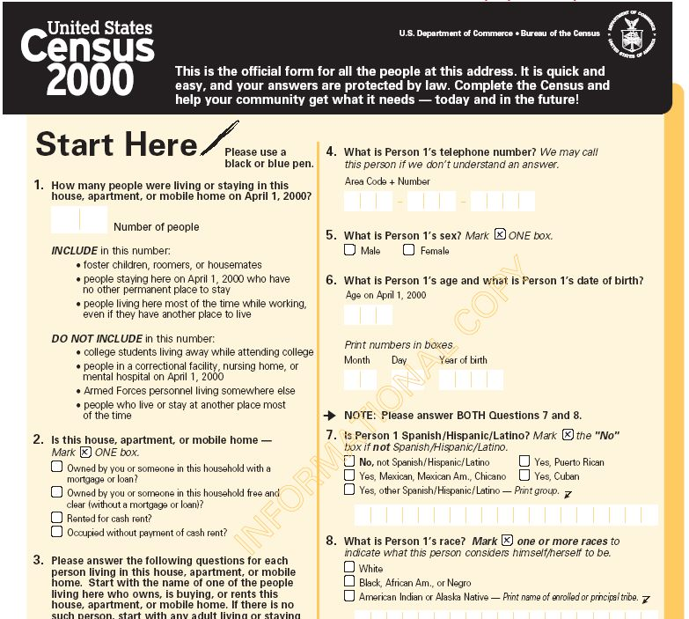
Global Instructions

Part II: Question-Level Fields and Categories 

This section contains information on the question-specific coding fields. These fields contain information that is applicable to the question, not necessarily the whole questionnaire. Some fields describe the physical layout of the question, while other fields describe the information contained within the question, as well as the error(s) that occurred (if any) when the question was tested. The units of analysis for the fields located in this section are at the question level.

Introductory Text
(Matrix: Overall Question or Instructions)

This field contains, if applicable, the text that occurs before the actual question. The introductory text provides the context for a coming set of questions, and is likely to contain a description of the subject matter, or specific instructions including the response categories for the series of questions or the time frame to consider. In the case of a matrix, this may appear as a heading, instructions, or question that apply to the overall matrix. Please include in your report the introductory text as it appears on the survey.

Categories: Verbatim Text

Example: “In this next set of questions, I will ask about INJURIES AND POISONINGS that happened in the PAST THREE MONTHS that REQUIRED MEDICAL ADVICE OR TREATMENT, including call to a poison control center.”

Figure 2: 2003 Annual Survey of Foreign Direct Investment in the United States—Introductory Text Example

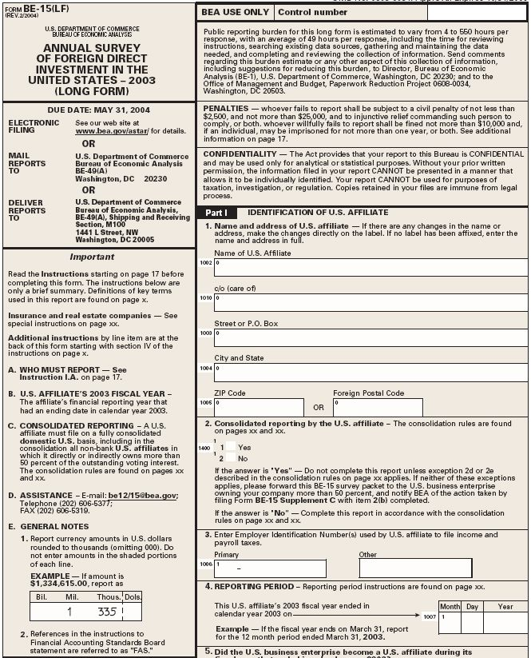
Introductory Text

Figure 3: 2004 National Census Test—Introductory Text Example

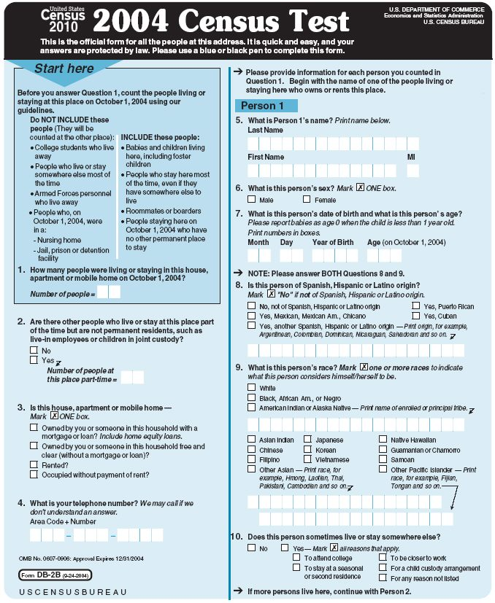
Introductory Text

Core Question

This field contains the core text of the question. Please include in your report every part of the question (except the response categories) so that it makes sense on its own. Therefore, if the front part of the question is broken apart and used for several questions, then that first part must be included when recording each question. Include definitions when they are embedded in the question (not as instructions but as definitions).

Categories: Verbatim Text

Example: Have you ever eaten…..
….lobster? Y/N
….steak tartar? Y/N
….sea urchin? Y/N

Record As: Have you ever eaten….steak tartar?

In forms that contain a matrix it may be more difficult to identify the core question or the item for an individual question. In a matrix, a series of questions are asked about a series of objects. The core question for a matrix is the question or statement that tells the respondent the topic of interest. The object is the person, place or thing that the question asks about, in relation to the topic of interest. In a matrix, core questions are either in the rows or columns. The core question solicits information across several objects. The core question is the type of information being solicited while the object is the dimension that is being measured.

Figure 4: 2005 American Community Survey—Core Question Example

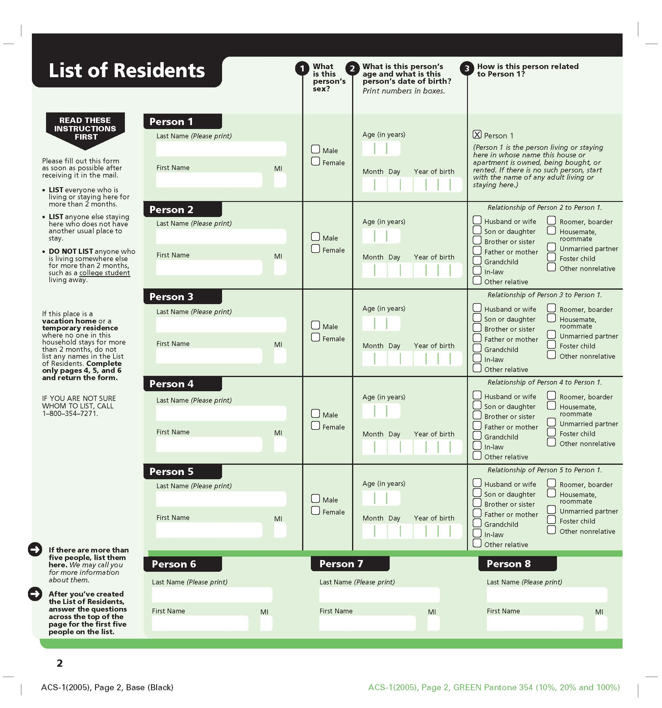
Core Question

Objects
(Applies to Matrix only)

This is a list of the persons, places or things that the question asks about. Write them verbatim with semicolons separating them.

Figure 5: BE-605, Transactions of a U.S. Affiliate…with a Foreign Parent—Object Example

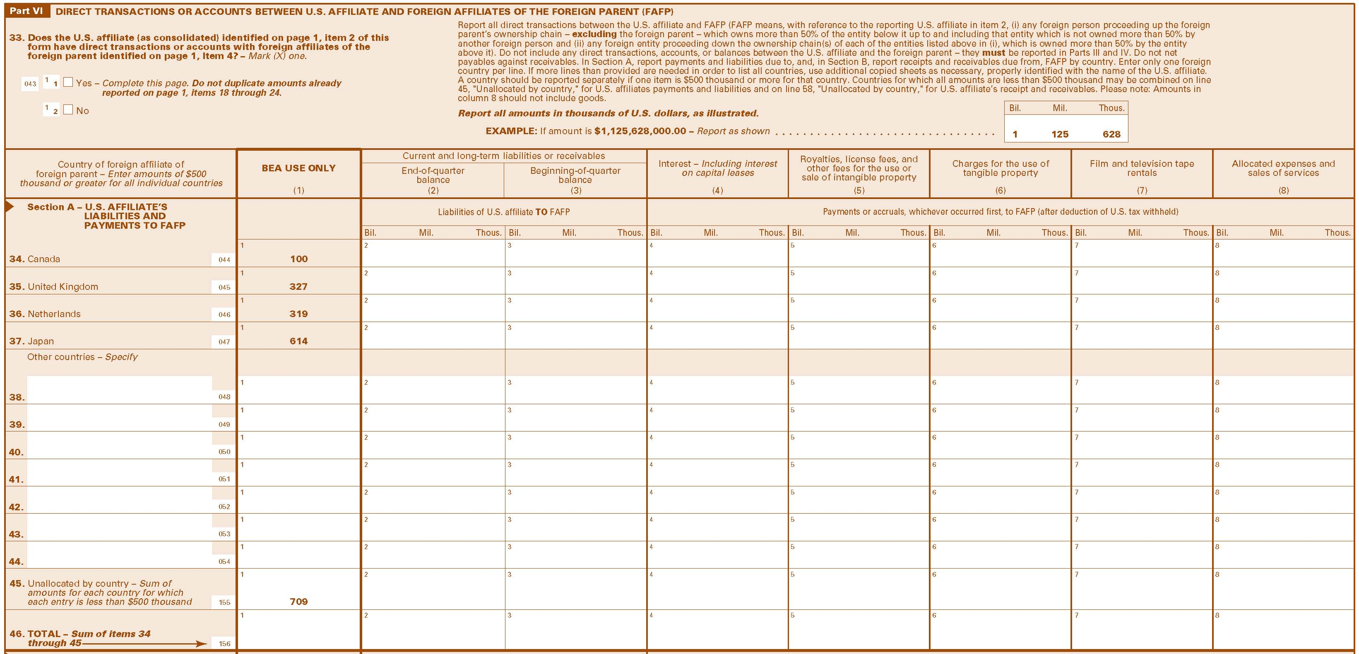
Objects

Objects: Canada; United Kingdom; Netherlands

Figure 6: 2005 American Community Survey—Object Example

Objects

Objects: Person 1; Person 2

Instructions Following Core Question

In self-administered surveys, instructions not only precede questions, but they often follow them as well. This field provides the instructions that appear immediately after a question, which apply to that question. Please include any instructions following a core question as they appear in the survey.

Categories: Verbatim Text

Example: “If the grandparent is financially responsible for more than one grandchild, answer the question for the grandchild for whom the grandparent has been responsible for the longest period of time.”

Figure 9: 2005 American Community Survey—Instructions Following Core Question Example

Instructions Following Core Questions or Items

Figure 10: 2003 Annual Survey of Foreign Direct Investment in the United States—Instructions Following Core Question Example

Instructions Following Core Questions or Items

Response Option Text

This field contains the response options given with the question. Please include in your report the verbatim text of the response options. If there is no text associated with the answer space, please indicate this using N/A.

Categories: Verbatim Text or N/A

Example: Yes
No

Figure 7: 2004 National Census Test—Response Option Text Example

Response Option Text

Figure 8: 2004 National Census Test—Response Option Text Example

Response Option Text

Instructions Following Response Options

Instructions may also follow the response options in self-administered surveys. This field provides the instructions that follow response options or the answer space. These instructions are often follow-up question or are skip instructions for the next question. Please include any instructions that follow response options as they appear in the survey and the response options they follow.

Categories: Verbatim Text

Example: “Yes – Mark X all reasons that apply.”

Figure 11: 2003 Annual Survey of Foreign Direct Investment in the United States—Instructions Following Response Options Example

Instructions Following Response Options

Figure 12: Census 2000 questionnaire—Instructions Following Response Options Example

Instructions Following Response Options

Information Type

The information type field is designed to distinguish between broad types of information that are often elicited through survey questions. The first category in this field is “events, actions, and behaviors,” which is assigned to questions about past or present behaviors or activities that respondents engage in. This type of question can generally be distinguished from a question about an “objective characteristic”—i.e., a non-behavioral attribute that describes a person or object. Questions such as “do you own a car” and “do you have diabetes” are examples. Objective characteristics are theoretically observable by an outsider, whereas the next category -“subjective characteristic”- refers to attributes that are not. An example of a subjective characteristic question would be “how healthy do you feel today” or other states of feeling. Another distinctive category is “attitudes/opinions” which call for evaluative judgments. Less common but still distinctive categories of questions ask for respondent “speculations” (e.g., whether they believe something will happen) or “knowledge tests” (e.g. questions which test respondents’ knowledge). These categories are designed to be mutually exclusive and as comprehensive as possible, capturing meaningful distinctions in relatively few broad categories. For question types that do not fit any of the above categories, please use the information type of “other”.

Categories: Events, Actions Behaviors
Objective Characteristics
Subjective Characteristics
Speculations
Attitudes/Opinions
Knowledge Tests
Other

Example: Objective Characteristics

Description of Information Types: (listed on next page)

Description of Information Types

TYPE | DEFINITION | EXAMPLES
Events, Actions, and Behaviors | - Describes an action or event  - Includes reports of past and present actions, habits, behaviors, events and practices  These reports are externally observable. They are not characteristics of people, households, or institutions, but represent some action that was taken. This category includes non-event questions, that is, when a respondent is asked to report whether an action or event did not take place. It also includes the naming of something related to an event. | Have you ever smoked a whole cigarette?  When did your injury/poisoning happen?  Did you ever have a heart attack?  Do you currently take insulin for your diabetes?  In the past 12 months, how many times have you seen or talked to a nurse for care or advice?  In the last 12 months, have you had surgery?  In the last 12 months, have your tonsils been removed?  What type of vehicle struck your vehicle?  During the past 12 months, has medical care been delayed because of worry about the cost?  Are you paying an additional premium for a supplemental health insurance plan?  Has a doctor ever told you that you have asthma?
Objective  Characteristics | - Describes characteristics of the respondent, household, household member, establishment, employee or some other group  - Is verifiable information  Objective characteristics are traits of individuals, households, or institutions. It can include something they have, received, are aware of, or were told about. For example, questions fitting into this category would include questions about whether people “have” a chronic condition, health insurance plan or whether they are aware of another kind of condition that they might have. Question coding is assessing whether the question content is objective, regardless of question design intent. | Do you have diabetes?  Do you have insurance that you purchase directly?  Do you have any type of government-sponsored insurance such as Medicare, Medicaid, Medi-GAP, or CHIP?  How old are you?  How old were you when you first started to smoke fairly regularly?  What is your weight?  Because of a health problem, are you unable to walk without using any special equipment?  What herbs are included in [combination herb pill#1]?
Subjective  Characteristics | - Describes characteristics of the respondent, household, household member, establishment, employee or some other group  - Is not verifiable information  A subjective characteristic is a personal state that is a matter of perception. Even if these characteristics were well-defined, they could not be externally verified, and there is no “true” answer. Question coding is assessing whether the question content is subjective, regardless of question design intent. | In general, how would you rate your health today?  Do you consider yourself to have a disability?  Do you need the help of another person with preparing meals? (as opposed to: Does another person prepare your meals for you?)  By yourself, and without using any special equipment, how difficult is it for you to stand or be on your feet for about 2 hours?  Overall in the last 30 days, how much distress, sadness or worry did you experience?  Because of a health problem, do you have difficulty walking without using any special equipment?
Speculations | Ask about intentions, predictions or hypothetical situations  Speculative questions are about events, behaviors, practices that have not yet occurred, or they present hypothetical situations to which the respondent must evaluate or provide prediction. Unlike “report” questions that inquire into past or present events, the tense of speculations is future or subjunctive. | Do you plan to visit the dentist in the next six months?  How likely are you to lose 10 pounds over the next year?  If you were in a car accident, who would you call first?  John cannot wash, groom or dress himself without personal help. He has no problems with feeding. How would you rate his difficulty with self-care?  What are your chances of getting HIV?
Attitudes/Opinions | Ask about Attitudes and opinions  The general format of these questions is to ask for an opinion, a preference, or a particular position. The response options generally appear in the form of a scale. | On a scale from 0 to 5 (with 0 being not at all and 5 being very strong), how strongly do you believe that children should be immunized?  Do you believe that immunizations are harmful to children under 2 years old?  Would you like to weigh more?  Do you believe that you are identified more often by other people as belonging to only one of these groups?
Knowledge Tests | Tests respondents’ knowledge  Knowledge questions verify the level of knowledge respondents have regarding a particular subject matter. They ask about externally verifiable facts, where some outside source of information will be considered as a “gold standard” and the point of the question is to see how well respondent knowledge compares to that standard  Include awareness about events or questions asking if someone has ever “heard of” a particular program. | Does trans fat raise blood cholesterol, lower it or have no effect on blood cholesterol?  Can you name the mayor of Baltimore?  Have you ever heard of Medicare?
Other | Question types that do not fit any of the above categories.

Response Category

The response category type field refers specifically to the format of information that a question is attempting to capture. For example, many questions solicit a “yes/no” response. Others questions ask respondents to select one answer from a list of responses—this could include questions with a list of response options and also scales (either numeric “from 1 to 10” or verbal, such as “excellent, good, fair, poor”). Other questions allow for multiple responses (i.e. “check all that apply”). A less common response category type is an allocation (e.g., assigning percentages across various categories).
Other questions ask respondents to provide numeric or textual responses in an open-ended manner, such as reporting the number of times that an event happened to them, the date of an event, or the name of their usual care provider. Responses to questions may also appear to be in both numeric and textual form. The following question provides an example.

How long has it been since you last visited a dentist or dental clinic?
- within in the past year (1 to 12 months ago)
- within the past 2 years (1 to 2 years)
- within 5 years (2 to 5 years)
- five or more years
- Don’t know/never/refuse

In this case, the response category would be select one numeric because the type of information the question is attempting to capture is numeric (how many years).

In self-administered surveys information is often provided to demonstrate how respondents should record their response. An open-ended textual or number delineated response category would provide markings to tell the respondent where each number or letter of their response should go (e.g., phone number: _ _ _-_ _ _ -_ _ _ _). See other examples of delineated and non-delineated fields below.

These categories are intended to be mutually exclusive. Please indicate one response category that best fits the information presented in the question.

Periodically, a questionnaire will have questions which appear to have multiple response category types. See example below.

What is your race? (Please mark one or more races)

- White
- Black
- Indian – Print name of tribe _ _ _ _ _ _ _ _ _ _ _ _ _ _
- Asian
- Other – Please specify _ _ _ _ _ _ _ _ _ _ _ _ _ _

Here the response category could appear to be both mark all that apply as well as open ended textual delineated. In these cases, please code the main response category. For this question, the response category would be mark all that apply.

Categories: Yes/No
Select one textual
Select one numeric
Mark all that apply
Allocation
Open-ended textual – Delineated
Open-ended textual – Non Delineated
Open-ended numeric – Delineated
Open-ended numeric – Non Delineated
Other

Figure 17: 2005 American Community Figure 18: 2005 American
Survey— Open-Ended Textual, Non Community Survey—Open-ended
Delineated Example Numeric, Delineated Example
Open-ended Textual—Non Delineated
Open-ended Numeric-- Delineated

Target Population

This field specifies who the question is inquiring about – the individual, household, or another type of establishment.

For population surveys the target population categories should be mutually exclusive. However, for establishment surveys, if the question is inquiring about more than one type of establishment, please indicate all that apply. Additional target population categories may be added for establishment surveys only. If possible, please select a category from the list below. If none of the categories are applicable you may indicate a new category to be added to the database.

Categories:

Population: Individual
Household

Establishment: School/Educational Institution
Farm
Hospital
Business
Other________

Sequence Number

This field denotes the number of the question within one introductory phrase or number of the question in a matrix. For example, if there are four core questions in a matrix, they would be numbered 1, 2, 3 or 4 for this field. The sequence number field is used only when the questionnaire contains introductory text. If there is no introductory text preceding the question, please write N/A in the sequence number field. Please note that sequence number starts over after new introductory text is presented (see example 3).

Category: Number (1 of 6) or N/A

Example 1:

Have you ever eaten…..
….lobster? Y/N
….steak tartar? Y/N
….sea urchin? Y/N

The question which asks about steak tartar would be recorded as 2 of 3, as it is question number 2 out of the series of 3 questions within one introductory phrase.

Example 2:

In this next set of questions, you will be asked about INJURIES AND POISONINGS that happened in the PAST THREE MONTHS that REQUIRED MEDICAL ADVICE OR TREATMENT, including calls to a poison control center.
(1) DURING THE PAST THREE MONTHS, that is, since May 1st 2006, were you injured or poisoned seriously enough that you got medical advice or treatment?
(2) How many different times in the PAST 3 MONTHS were you injured or poisoned seriously enough to seek medical advice or treatment?
(3) When did your injury/poisoning happen?
The first question in the series following the introductory text would be labeled sequence 1 of 3, the second question would be labeled sequence 2 of 3, and the third question would be labeled sequence 3 of 3.

Example 3:

Now we’d like to know what recommendations you may have heard regarding physical activity, nutrition, and protecting oneself from the sun.

1) What is the recommended minimum number of days per week an average adult should be physically active to achieve a health benefit?

2) What is the recommended minimum number of minutes an average adult needs to be physically active during most days of the week in order to achieve a health benefit?
I’m going to read you three statements concerning physical activity. For each, just tell me if you think it’s true, false, or you don’t know.

3) The first statement is: The average adult must exercise vigorously to achieve a health benefit. (Would you say that is true, false, or you don’t know.)

The sequence number for question 1 would be 1 of 2 and the sequence number for question 2 would be 2 of 2. However, the sequence number for question #3 would 1 because of the second set of introductory text preceding question 3.

Example 4:

The following questions are about discussions doctors may have with their patients about the PSA test that is used to look for prostate cancer.

- Discussion of clinical issue or nature of decision
Have you and a doctor ever talked about the PSA test?
- Discussion of pros and cons of alternatives
Which of the following topics about PSA tests have you ever talked about with a doctor? Have you talked about:

2. 1 the PSA test’s effect on your peace of mind?
2. 2 the PSA test’s chances for giving wrong results?

- Discussion of uncertainty
Has a doctor ever mentioned to you that experts have different opinions about the PSA test?

For this set of questions the sequence numbering would begin with the first question following the introductory text marked as sequence number 1 or 4. Question 2.1 would be entered as sequence number 2 of 4 and question 2.2 would be entered as sequence number 3 of 4. Finally, question number 3 would be entered as sequence number 4 of 4.

Figure 19: BE-605, Transactions of a U.S. Affiliate…with a Foreign Parent—Sequence Number Example

Sequence Number:
2 = End-of-quarter
3 = Beginning-of-quarter
4 = Interest
etc.

Figure 20: 2005 American Community Survey—Sequence Number Example
Sequence Number

Response Error
(Self-Administered Population Questionnaires)

The response error field denotes the type of question design error(s) identified in the cognitive testing. This field provides information on the types of error occurring within the question itself. All questions that are coded for response error must include empirical evidence in the report, which provides a convincing argument and enough description to show that the error exists. Please code response errors based only on the information provided in the evaluation summary for that question. Do not code potential problems identified based solely on expert review. If more than one error is found during the evaluation of question, please mark all the response errors that apply. However, only one response error code can be used per problem. If it appears as if two different response error codes could be applied to a single problem, please select the response error that emerges as the root of the problem. . If results from multiple rounds of testing are presented in one report please code all versions of the questions that elicited sufficient evidence to support a code. If the same question was tested during multiple rounds, please code all errors that were elicited in all rounds.
Response error may appear in the introductory text, the question itself, or in the response errors. Please indicate error if it occurs in any of these parts of the question. Please note however, introductory text cannot be entered into Q-Bank without a corresponding question.
The response error field denotes the type(s) of error(s) identified in the questionnaire evaluation. The first few categories of the taxonomy cover problems with terms or concepts. The first category is “problematic terms”. This response error occurs when the question contains inappropriate or unfamiliar terms. For example, respondents who answered a question about the use of dosimeters did in fact use such a device, but did not recognize it by that name. A related category focuses on “ambiguous concepts”. This category contains response errors that occur due to unclear and vague concepts. One such example is a question about whether a respondent works near a large electrical machine. The words utilized in the question are readily familiar, but the term “large electrical machine” is considered an ambiguous concept. This is evidenced by four respondents who worked near a drill press answering yes because they thought that the machine qualified as large. But, three other respondents, who also worked near a drill press, saw the machine as relatively small, therefore, responded no to the question. As a result, respondents in exactly the same situation characterized themselves differently due to this ambiguous term.
A third conceptual problem, “assumption/double barrel” include questions that make an assumption that may be false or only apply to a subset of respondents, or questions that ask about two different topics but assume a single answer. The following question is an example of a question that elicits an assumption response error.

(Would/Do) any of these affect whether or not you use acupuncture?
(a) Friends or family recommended it? Yes no don’t know
(b) A medical doctor recommended it? Yes no don’t know
(c) Insurance paid for it? Yes no don’t know

When tested, it was shown that this question made an implicit assumption that respondents did not want to use acupuncture and therefore, would have to be persuaded by somebody (or something) in order to do so. This was a faulty assumption for those respondents who wanted to use acupuncture, but in their words, simply “haven’t gotten around to it.” Because the question makes a faulty assumption, an answer of “no” isn’t exactly correct. Double barrel questions ask respondents about two different concepts but assume a single answer. The following question is an example of a question which elicited a double barrel response error.

As a result of this injury/poisoning, how much work did (you/participant name) miss?
- Not employed at the time of the injury/poisoning
- None
- Less than 1 day
- One to five days
- Six or more days
- Refused
- Don’t know

This question attempts to find out if the respondent was employed at the time of the injury (via the response option “not employed at the time of the injury,” as well as the number of days missed. From the respondents point of view, it was shown that the question itself assumed that the he/she was employed at the time of the injury, and occurred that the unemployed or retired respondent answered “none” (because, indeed, they did not miss any days of work)—this error especially occurred if they answered before hearing the response categories. The two categories “assumption” and “double barrel” have been combined as it is often difficult to distinguish between the two.

Two categories were designed to indicate various recall or judgment problems in the response process. One of these categories, “recall/estimation difficulty”, reflects a variety of situations where respondents have difficulty remembering information or might not know it at all. For example, a question that asked whether respondents experienced symptoms of asthma before they were two years old, presented a situation in which respondents could not remember firsthand and did not know at all unless someone told them. Another category was created for “biased/sensitive” questions, used to denote unintentional influences on response accuracy that might suggest a particular answer was more correct or desirable than others.
Some other categories focus more on structural problems with the questions. The “overly complex” category is used to denote questions that are long, complex, grammatically twisted, or overly laden with clauses. Another category, “inadequate response options” is largely self-explanatory. This category applies when important response options are missing from the question, the provided response units don’t make sense, or related problems. “Not seen/read” deals with the perception problem that precedes the comprehension stage in which the respondent either does not see, or chooses not to attend to a piece of the item, which could be the instruction, part of the question text or the response text.
Finally, additional problems may occur as a result of the formatting of the questionnaire. “Questionnaire effects” is used not to denote problems with particular questions, but rather problems emerging from a particular juxtaposition of questions. Examples could include bad flow, apparent context effects, skip problems, and so on. “Problematic answer space” deals with any difficulty the respondent could have entering their chosen answer onto the space provided on the form. “Problematic visual cues” include any visual stimulus that could mislead the respondent. These could be inadequate or ambiguous visual or navigational cues, such as skip patterns that are not easily followed, directional symbols that are not well understood, or misuse of italics. Problematic visual cues could also be cues that are inconsistent, for example, using the phrase “skip to” sometimes and “go to” other times within a questionnaire to indicate a skip pattern or using the bolding and italics interchangeably throughout the questionnaire.
There may be cases where it is difficult to select a response error code based on the way the errors emerged in the evaluation or based on the way the evaluation results are summarized. For instance, older reports may be written in a way that does not fit the Q-Bank response error coding scheme. Also, there may be cases where no response category will fully capture the response error occurring in the question evaluation. In these instances please use the response error category “response error N.E.C. (not elsewhere coded).” If no errors were discovered during the question evaluation please indicate this using the category “none as tested.”
Errors that occur as a result of problematic instructions or introductory text may be coded as well. However, when instructions are provided in a separate booklet or document, they may not be coded as eliciting a response error. The following questions provide examples of items where the instructions are embedded within the question, as opposed to being placed in a separate document.

Example:

What kind of health insurance or health care coverage do you have? Include those that pay for only one type of service (nursing home care, accidents, or dental care). Exclude private plans that only provide extra cash while hospitalized.

During testing respondents reported having trouble with the overuse of qualifiers, which led to misreporting of their health insurance/health care coverage. The type of error occurring in this question would be “overly complex.”

Example:

INTRO:
I am going to ask you about the time you spent being physically active in the last 7 days. Please answer each question even if you do not consider yourself to be an active person. Think about the activities you do at work, as part of your house and yard work, to get from place to place, and in your spare time for recreation, exercise or sport.

First, think about all the vigorous activities which take hard physical effort that you did in the last 7 days. Vigorous activities make you breathe much harder than normal and may include heavy lifting, digging, aerobics, or fast bicycling. Think only about those physical activities that you did for at least 10 minutes at a time

PAB1. During the last 7 days, on how many days did you do vigorous physical activities?

During cognitive testing the introductions and instructions were found to be very long and often had to be repeated. Details contained in these introductions often got lost. The type of error occurring in this question would be “overly complex.”

If multiple errors were discovered during the pre-testing of the questions, please indicate all that apply. However, if you use the category “none as tested” no other response errors may be applied to that question.

Categories:

- Problematic Visual Cues
- Not Seen/Read
- Problematic Terms
- Ambiguous Concepts
- Overly Complex
- Assumption/Double Barrel
- Questionnaire Effects
- Recall /Estimation Difficulty
- Biased/Sensitive
- Inadequate Response Options
- Problematic Answer Space
- Response Error N.E.C
- None as Tested

Example: ambiguous concept, not seen/read

Response Error Indicators, Self-Administered Questionnaires: (listed on next page)

Response Error Indicators (For Self-Administered Questionnaires)

The following table provides definitions of the response error categories and examples of questions which may elicit these types of errors. Remember it is important that all response error codes be applied based on problems that were identified during the question evaluation. A question that has not been adequately tested cannot be labeled as containing an error based on the question text alone.

ERROR TYPE | DEFINTION | EXAMPLE
COMPREHENSION
1. Problematic Terms | Contains inappropriate or unfamiliar terms  - Unknown terms  - Terms used out of context or inappropriately  - Overly technical language/jargon | Have you ever used a dental sealant? (respondents did not know term ‘dental sealant’)  How often do you use a dosimeter? (respondents did not know term ‘dosimeter’)
2. Ambiguous Concepts | Contains vague or ambiguous concepts  - Ambiguous or vague concepts or terms  - missing reference period  - concepts with multiple interpretations - answer could vary depending upon which interpretation was taken  - Instructions or definitions are missing or inadequate | How many hours a week do you work near a large electrical machine? (A respondent constantly passed by a machine for a few seconds, and was unsure whether that was considered working near? Large is vague; some respondents categorized a drill press as large, while other respondents did not.)  Do you need the help of other persons in handling personal care needs? (Respondent did “get help” but did not “need help”; they were unsure which answer was most appropriate.)  Did you have sex with your current partner? (Respondents did not know what the term sex was referring to→Could refer to intercourse or other forms of intimate contact; their answers varied depending upon interpretation.)  What is the recommended SPF number in sunscreen that you should use to prevent skin cancer? (The subject in this question, “you”, is ambiguous because respondents were unsure whether they should be responding for themselves or for a people in general.)
3. Overly Complex | Question is long or overly complex  - Respondents are unable to remember or synthesize the details in the question because of the length  - Overuse of qualifiers, such as “including” and “not counting”  - Important ideas are missed because they are buried within the question  - Unnecessary grammatical complications (e.g. double-negatives) or awkward structure | Do you have any difficulty hearing, seeing, communicating, walking, climbing stairs, bending, learning or doing any similar activities? (Respondents had trouble remembering examples)  What kind of health insurance or health care coverage do you have? Include those that pay for only one type of service (nursing home care, accidents, or dental care). Exclude private plans that only provide extra cash while hospitalized. (Respondents had trouble with use of qualifiers and misreported)  In the past 12 months, how many times have you seen or talked on the telephone about your physical, emotional or mental health with a family doctor or general practitioner? (Many did not hear “seen” and responded with only the number of times spoken on the telephone)
4. Assumption/ Double Barrel | Question makes inaccurate assumption about respondents’ experiences  Question asks about two different concepts, but assumes a single answer | When did you stop beating your wife? (Assumed the respondent has done this.)  When riding in the back seat of a car, how often do you wear a seat belt? (Assumed that the respondent ever rides in the back seat of a car.)  Do you think women and children should have universal health care coverage? (Respondents who thought children should, but not necessarily women, were unsure how to answer.)  As a result of this injury/poisoning, how much work did you miss? (Respondents who were jobless misreported by saying that they did not miss any work→they had no work to miss)
RETRIEVAL
1. Recall/Estimation Difficulty | Respondent does not know or has difficulty recalling information.  Response is subject to error because of calculation or estimation difficulty.  The difficulty may be because of memory trouble or because the respondent never knew the information to begin with.  - Topic is of low salience to R (especially for attitude questions)  - Question asks about information the respondent is unlikely to know  - Telescoping: Specific recall problem where events before the reference period are recalled as being within the reference period.  - Requires broad reliance on estimation (a wild guess is the best possible result).  - Guessing or assuming the answer – ball parking  - Trouble making calculations in head | What is the dosage of your asthma medication? (respondents had difficulty estimating response)  In your lifetime, with how many people have you had sex? (respondents had difficulty calculating response)  Do you think the Lt. Governor of Delaware has been doing a good job? (respondents had difficulty because they did not know information)  On what date did you first ride a bicycle?  (respondents had difficulty due to recall issues)  In the past three years, how many times did you visit a doctor? (respondents had difficulty estimating response)  In your lifetime, how many cigarettes have you smoked? (respondents had difficulty calculating response)  Asking floor manager about hours that the office staff works. (respondent did not have enough information to answer question)  Asking proxy for information proxy is not likely to have. (respondent did not have enough information to answer question)
JUDGEMENT
1. Biased/Sensitive | Response process is influenced by either the sensitive or social context of the question topic.  The format of the question text or response options produces unintentional influences on the response process. | Are you in favor of allowing the interests of big business to dominate the Congressional agenda, or are you in favor of sensible legislation to moderate the influence of outside lobbyists? (respondents felt pressured to select second option)  With how many men have you had sex?  (respondents felt uncomfortable with answering this question)  People in the United States are from many countries, tribes and cultural groups. What is YOUR/NAME’S ancestry or tribe? For example, Italian, African American, Dominican, Aleut, Jamaican, Chinese, Pakistani, Salvadoran, Rosebud Sioux, Nigerian, Samoan, Russian, etc.  (Rather than viewing the list of ancestries as examples, respondents viewed the list as an exhaustive list of choices)
STRUCTURAL
1. Inadequate Response Options | Response options are incomplete, inadequate or overlapping  - R cannot adequately express their response given the categories provided  - Non-mutually exclusive response options; two categories could apply, but only one can be selected  - Response options do not fit the question  - Response units are inappropriate  - Response categories include a problematic term, are ambiguous, or are overly complex  - Length of response options places burden on respondent, causing respondents to overlook appropriate responses or to choose the first response that appears to be appropriate without considering subsequent responses | Do you NOW smoke cigarettes every day, some days or not at all? (Many people wanted to report “many days” because “some days” seemed like not enough)  What was the reason that you had a mammogram?[Pick one: Regular check up, doctor suggested it, had concern that there was a problem, thought it was time to get one.] (respondents felt the list of reasons were inadequate)  Does a long-term physical condition or mental condition or health problem, reduce the amount or the kind of activity you can do at home? Sometimes. Often or Never.  (respondents felt response options were inappropriate)  How many canisters of asthma medications do you use per month?  ______ Number of canisters  (Most respondents used no more than one canister per month)
2. Not Seen/Not Read | Respondent either does not see or chooses not to attend to a piece of the item, which could be an instruction, part of the question text or the response text.
3. Questionnaire Effects | Question problem related to the questionnaire  Question would not necessarily have a problem independently, but there is a problem related to the entire questionnaire.  - Illogical juxtaposition of topics/awkward flow  - Response of question is impacted by previous questions (i.e. context or order effects)  - Inconsistent verbal format across similar or related questions  - Questions are perceived to be repetitive  - Burdensome length of the questionnaire  - Apparent omissions that confuse or irritate respondents. | Do you have chronic bronchitis?  Do you have coronary heart disease?  What was you total household income before taxes in 2002? (respondents were confused by illogical flow)  Series of questions about exercise where “no” responses started to create an image of inactivity which made the respondent uncomfortable; questions that respondents seem reluctant to answer  Most questions in the series ask “agree/disagree,” but then a few switches to “true/false”(confused respondent)  In the 2 years before your first positive HIV test, how many times were you tested for HIV?  How often did you get tested for HIV in the 2 years before your first positive HIV test?  (respondents were confused due to the repetitiveness of questions)  R complains about length or does not concentrate to provide accurate information  In a questionnaire for truck drivers about toxic exposures, R comments that there were no questions about exhaust from other cars, which is one of the worst problems.
4. Problematic Answer Space | Any difficulty experienced by the respondent when attempted to record their response onto the form.
5. Problematic Visual Cues | Any visual stimulus that could mislead the respondent. These include:  - Inadequate or ambiguous visual or navigational cues, such as skip patterns, directional symbols that are not well understood or misuse of italics  - Cues that are inconsistent, such as using skip to and go to within same questionnaire or using bolding and italics interchangeably
OTHER
1.Response Error N.E.C. | Use for problems where it is difficult to select a response error code based on the way the errors emerged in the evaluation or based on the way the evaluation results are summarized.
2. None as Tested | No errors were detected during the pre-testing of the question.

Response Error
(Additional Establishment Response Errors)

In addition to the self-administered response errors listed in the previous page, establishment surveys elicit a set of unique response errors as a result of the reporting process. The following response error indicators appear only when questions from establishment surveys are being entered into the database or are the topic of a search.
Retrieval from records encompasses five potential response error indicators. A “mismatch between reporting and organizational unit” occurs when the reporting unit for which data are requested does not match the respondent’s organizational or accounting structure. A “mismatch between requested data and records” occurs when the data for the topic of interest exists in records, but not in the manner requested. “Requested data not kept in records” happens when a survey asks for information that is not tracked in records at all. “Lack of access to requested data” indicates that the data exists in records, but the respondent has not been granted access to that information. “Decentralized data” signifies that the requested data does not reside in one location or with one respondent. It is necessary to consult multiple sources to retrieve information.
Additionally, in establishments, when a respondent makes a judgment about how to report something, they are not only making a personal judgment (i.e. should I estimate, or try to calculate the answer?), but they are also considering authority and policies concerning reporting company data to an external entity. For this reason, we differentiate between personal judgment errors and policy imposed judgment errors.
Personal judgment errors are broken down further into three categories that were created to reflect errors that occur at the level of the respondent as an individual, not the establishment as a whole. The first category, “estimation” represents errors that occur based on respondent’s error in estimating rather than errors in the actual figures. Note this category replaces the recall/estimation category used for self-administered population surveys. “Calculation/transformation of data” type errors may occur when a respondent commits an error when asked to calculate figures that could be calculated on the processing side of data collection. (e.g., asking respondents to sum figures in a table). “Perpetuating prior incorrect reporting strategy” occur when the respondent uses an erroneous strategy that had been used in the past for reporting this type of data, instead of reading instructions and generating the requested data.
Finally, response errors may occur as a direct result of policy imposed judgments. There are three different reasons for why data is not released. The “release of data is prohibited”, the establishment is “Not willing to divulge propriety information” or the “release of data conditional upon authorization”.
For establishment surveys, please use any of the response errors listed under population self-administered surveys in addition to these response errors for establishment surveys.

Categories:

- Problematic Visual Cues
- Not Seen/Read
- Problematic Terms
- Ambiguous Concepts
- Overly Complex
- Assumption/Double Barrel
- Questionnaire Effects
- Biased/Sensitive
- Inadequate Response Options
- Problematic Answer Space
- Mismatch between reporting unit and org unit
- Mismatch between requested data and records
- Requested data not kept in records
- Lack of access to requested data
- Decentralized data
- Release of data prohibited
- Not willing to divulge proprietary information
- Release of data conditional upon authorization
- Estimation
- Calculation/transformation of data
- Perpetuating prior incorrect reporting strategy
- Response Error N.E.C
- None as Tested

Example: Release of data is prohibited

Response Error Indicators, Additional Establishment Questionnaire Response Errors: (listed on next page)

Response Error Indicators (Additional Establishment Questionnaire Response Errors)

ERROR TYPE | DEFINTION

RETRIEVAL ERROR
1. Mismatch between reporting and organizational unit | The structural unit for which data are requested does not match the respondent’s natural or structural way of organizing information.
2. Mismatch between requested data and records | The data for the topic of interest exists in records, but not in the manner requested.
3. Requested data not kept in records | The survey asks for information that is not tracked in records at all.
4. Lack of access to requested data | Data exists in records, but the respondent has not been granted access to that information
5. Decentralized data | The requested data does not reside in one location or with one respondent. It is necessary to consult multiple sources to retrieve information

PERSONAL JUDGMENT
1. Estimation | Errors that occur based on respondent’s error in estimating rather than errors in the actual figures.
2. Calculation/transformation of data | A respondent commits an error when asked to calculate figures that could be calculated on the processing side of data collection. (e.g., asking respondents to sum figures in a table
3. Perpetuating prior incorrect reporting strategy | Respondent uses an erroneous strategy that had been used in the past for reporting this type of data, instead of reading instructions and generating the requested data.
POLICY IMPOSED JUDGMENTS
1. Release of data is prohibited | Release of the data is prohibited due to establishment policy.
2. Not willing to divulge propriety information | Respondent is not willing to divulge proprietary information due to establishment policy.
3. Release of data conditional upon authorization | Establishment policy states that the release of data is conditional upon proper authorization.

Where the Error Occurs

This field denotes where an error occurs in the questionnaire. For self-administered surveys it is important to determine whether the error occurred in the question itself or in the heading or label, the contextual instructions, the navigational direction, the response options, or in non-verbal components of the questionnaire. Non-verbal components are defined as including the “numeric, symbolic and graphic information (color brightness, shape and location of information). If error occurs in multiple locations, please indicate all that apply. If no response error is identified during testing please indicate not applicable.

Category: Heading/Label
Question/Item
Contextual Instruction
Navigational Direction
Response Option
Non-Verbal Components
Not applicable

Example: Heading/label, non-verbal components

Figure 16: 2004 National Census Test—Where an Error Could Occur Example
Introductory Text Format: Heading/Label
Introductory Text Format: Contextual Instructions

Respondent Role

This field specifies who is responding to the question – whether the report is for the self, another person (proxy), or both for a household survey, or the job title of the person targeted in an establishment survey. Respondent role may change throughout a questionnaire. Please indicate the respondent role for each question.

Additional respondent role categories may be added for establishment surveys only. If possible, please select a category from the list below. If none of the categories are applicable you may indicate a new category to be added to the database. Multiple respondent roles may be selected for a question.

Categories:

Population:
Self
Proxy
Self and Proxy

Establishment:
Accountant
Dean
Principal
President
Other_______

Index Status

The field denotes whether or not the question is part of an index or a mathematically linked set of questions. These include items that are used to calculate a figure outside of the survey instrument. It does not include items that could possibly be used to calculate an indicator. If you are unsure as to whether or not a question is part of an index, please mark no.

Categories: Yes
No

Example of a series of questions are considered to be part of an index:

1. Including yourself, how many people live here and have no other place they live?

2. Besides those counted in Question 1, how many other people have more than one place they live, but sleep here more often than anywhere else?

3. Besides those counted in Question 1 or 2, how many other people were staying here temporarily on January 3, 2005 and had no other place where they live?

These questions would all be considered to be part of an index because the summation of the responses given to each question is used by the Census Bureau to calculate the total number of people living in the household.

Example of a series of questions that are NOT considered to be part of an index:

A. What were the total receipts and other operating revenues for the locations identified in item 2?
> Note the sum of items 3A1 and 3A2 should equal item 3A.

A1. What were commissions and selling or listing fees?

A2. What were product sales on your own account and other operating revenue?

While the summation of answers to question A1 and A2 should equal the answer given in 3A, these questions are not considered part of an index.

Question Topic

This field indicates the general topic of the question. The question topic is sometimes determined by the section in which it appears in the survey.

The question topic field assigns one of several broad categories (e.g., demographics, health insurance, income) to each question. Thus, a user could use this field to identify all questions about, say, health insurance, that are in the database. The categories to be included in this field are designed to be specific enough to provide meaningful distinctions without being so narrow that very few questions would ever fit under the category. Thus, a category such as “health” is far too broad, but “HMO use” is too narrow. Rather than attempt to define all possible categories in advance, this field is open to change as new reports are coded into the database.

If possible, please select a category from the list below. If none of the categories are applicable you may indicate a new category to be added to the database.

Category: (listed on next page)

Question Topic – Population Surveys
Crime  Assault  Burglary  Computer Crime  Domestic Violence  Identity theft  Property Crime  Rape  Robbery  Theft  Weapons  Demographics  Age  Ancestry  Date of Birth  Educational Status  Employment Status  Ethnicity  Gender or Sex  Household Roster & Composition  Marital Status  Military Service  Race  Relationship  Residency  Sexual Identity  Education  Extracurricular Activities  School Environment  Student Performance  Truancy  Drug/Alcohol Education  Heath  Access to Health Care  Alternative Medicine  Children’s Mental Health  Disability  Erectile Dysfunction  Health Conditions  Health Information  Health Insurance  Health Recommendations  HIV/AIDS  Hospitalization  Hypertension  Injury  Injury and/or Poisoning  Mental Health  Nutrition  Oral Health  Physical Health | Poisoning  Prescription Medicine  Prostate Health  Rectal Health  Self Rated Health  Sexual Behavior  Skin Cancer  Sleep  Vaccinations  Income Sources and Assets  Home Ownership  Household Income  Earnings  Interest and Dividends  Child Support and Alimony  Public Assistance Programs  Child Care Subsidies  Food Stamps  Job Training Programs  SSI  TANF (formerly AFDC)  Transportation Subsidies  Social Problems  Discrimination  Substance Use  Catastrophic Events  Disaster  Terrorism

Question Topic - Establishment Surveys
Assets – Monetary  Assets – Physical  Building(s)  Equipment  Inventory  Land  Assets – Nonphysical  Copyright  Trademark  Patent  Business owner(s)  Demographic characteristics  Role in business  Contact information  Contractors  Contracts  Customer Type  Depreciation  E-commerce  E-government  Employment/Employees  Education level  Full-time/part-time  Full-time equivalents (FTEs)  Gender  Hours worked  Leased employees  Number  Temporary employees  Type of employees  Visa status  Expenses  Administrative  Equipment / supplies  Interest  Research & development  Services  Software  Structures  Utilities  Exported goods / services  Fiscal year  Foreign Operations  Fringe Benefits  Health insurance  Life insurance  Medicare  Other fringe benefits  Stock option  Retirement | Identification  Imported goods / services  Inventory  Lease/rental  Liabilities/Debts  Orders  Organizational change  Owner/stockholder equity  Payroll  Production  Actual operations  Full production  Market value  Work patterns  Public services  Reporting period  Sales/Receipts/Revenues  Source (of sales/receipts/revenues)  Volume (of sales/receipts/revenues)  Services  Interest  Research & development  Utilities  Administrative  Shipments  Structure/characteristics of enterprise/establishment  Business type  Franchise status  Industry  Legal form of organization  Number of establishments  Physical location / geography  Reporting unit  Taxes/fees collected  Income taxes  License taxes  Other taxes  Property taxes  Sales taxes  Taxes/fees paid  Income taxes  License taxes  Other taxes  Property taxes  Sales taxes  Vehicle(s)  Website
Page Number

This field denotes the number of the page in which the question appears within the questionnaire.

Categories: Page X of Y

Example: 2 of 10

Layout of Questions and Response Options

This field denotes the location of the question in relation to the response options. If there is only one response option, then two possibilities exist: the question is either located above or to the left of the one option. However, if there is more than one set of response options, the question may be located above the response options or to the left, and response options can either be aligned horizontally or vertically. For an example, see box below.

Response Options | Question Above | Question Left
Horizontal | What is your sex?   M F | What is your sex? M  F
Vertical | What is your sex?  M   F | What is your sex? |  M  F

Also, the question many appear above or to the left and the response options can be aligned both horizontally and vertically.

Response Options | Question Above | Question Left
Horizontal & Vertical | What is your race?   White  Black  Asian Am. Indian | What is your race? |  White   Asian | Black  Am. Indian

The categories are intended to be mutually exclusive. Please select the category that best fits the format of the question.

Categories:
Question Above Response Options
One RO
Vertical ROs
Horizontal ROs
Vertical and Horizontal ROs

Question Left of Response Options
One RO
Vertical ROs
Horizontal ROs
Vertical and Horizontal ROs

Location of Question

The field is intended to indicate the location of the question on the page. Please code only the questions in the extreme positions of the page as top or bottom. Only the first question on the page in the left column is to be coded “top left” Similarly, only the last question at the bottom of the left column should be coded as “bottom left.” All other questions should be coded as “middle.” If there are two columns of a page, please indicate if the question appears in the “middle left” side of the page or the “middle right” side of the page.

Categories: Top
Top Left
Top Right
Middle
Middle Left
Middle Right
Bottom
Bottom Left
Bottom Right

Example: Top Left

Figure 21: Census 2000 questionnaire—Location of Question Example

Top Right
Top Left

Response Option Text Location

This field denotes the location of the response options text in relation to the response box or answer space. Response options may appear to the right of, left of, below or above the response space. See examples below

Right | Left | Above | Below
_____ Year | Year _____ | Year  _____ | _____  Year

In addition, the response option text can appear in the response space. See examples below.

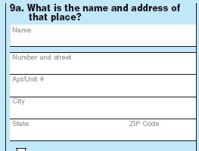



Periodically, a questionnaire will have questions which ask respondents to select an answer from a list, as well as a field where text may be entered in. See example below.

What is your race? (Please mark one or more races)

 White
 Black
 Indian – Print name of tribe _ _ _ _ _ _ _ _ _ _ _ _ _ _
 Asian
Other – Please specify _ _ _ _ _ _ _ _ _ _ _ _ _ _

Here the response option location could appear to be the right or the left of the answer box/space. In cases such as these please code the main response option text location. For this question, the response option location would be to the right.

These categories are considered to be mutually exclusive. Please select the category that best fits the location of the response option text. . If there is no text association with the answer space please indicate this using N/A.

Categories: Right
Left
Above
Below
In response space
Not Applicable

Separate Instructions

This field indicates whether the form, in which the question is found, has separate instructions from the rest of the survey. Also, this field indicates instructions that are not near the associated question but are item-by-item in nature. Separate instructions may appear at the beginning of the questionnaire, at the end, or in a separate booklet. An example of separate instructions would the IRS form guide, which is provided in a separate booklet from the actual form. Please indicate whether there are separate instructions associated with the question and be sure to include the separate instructions with your report.

Categories: Yes
No

Core Question Format

This field denotes the format of the ‘core question’ text. More specifically, it denotes whether the text appear as a question, as a single word or phrase (i.e., heading/label), or as some kind of instructions or directions.

These categories should be considered mutually exclusive, please select one only.

Categories: Heading/Label
Instruction/Statement
Question

Example: Instruction: Enter this person’s sex. Enter this person’s age.

Figure 23: 2003 Annual Survey of Foreign Direct Investment in the United States—Core Question Format Example, Heading/label
Core Question Format: Heading/label

Figure 24: 2005 National Census Test—Core Question Format Example, Instruction
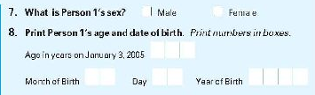
Core Question Format: Instructions

Figure 25: 2004 National Census Test—Core Question Format Example, Question
Core Question Format: Question
Introductory Text Format

This field denotes the format of the introductory text. This field describes whether the introductory text takes the form of a heading or label, contextual instructions navigational directions or some combination. Headings or labels are basically sentence fragments or phrases. Contextual instructions provide respondents with instructions that are necessary to answer the question correctly, and navigational directions tell respondents how to move through the questionnaire.

Introductory text may include multiple formats. Please indicate all that apply. If there is no introductory text associated with the question please indicate not applicable.

Categories: Heading/label
Instruction
Navigational Direction
Question
Not Applicable

Example:

Heading: Part 1 Identification of U.S. Affiliate –Continued

Instruction: Industry classification of fully consolidated U.S. affiliate (based on sales or gross operating revenues)—Enter the 4-digit International Surveys Industry (ISI) code(s) and the sales (as defined in item 55 on page 6) and employment associated with each code.

Question: What amounts were paid to FAFPs (or were entered into inter-company accounts, whichever came first) during the quarter, by country, and what were the debt balances with the FAFP at the beginning and end of the quarter, by country?

Figure 22: 2004 National Census Test—Introductory Text Format Example
Introductory Text Format: Heading/Label
Introductory Text Format: Instructions

Matrix Status

This field denotes whether or not the question is part of a matrix. A matrix is a grid in which a series of questions are asked about a series of objects, where one must look at the row and column, in deciding what to place into the answer cell.

Categories: Yes
No

Figure 13: Alternative Design of Form BE-605—Matrix Example
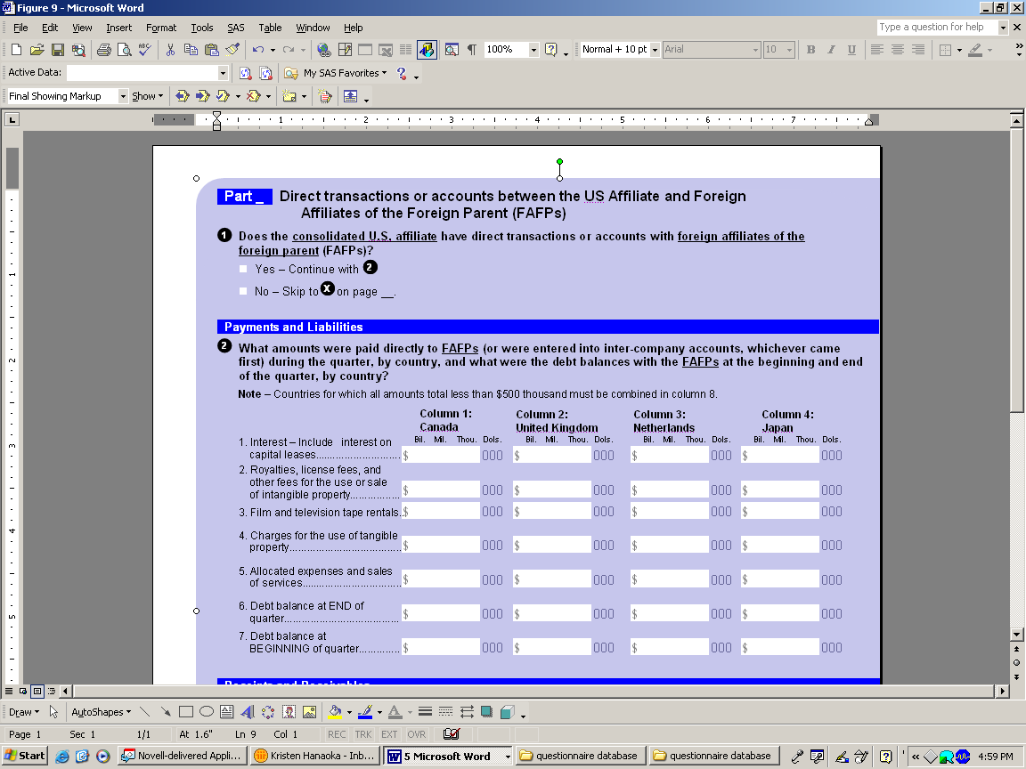

Orientation of Core Questions

This field denotes the location of the core question within the matrix. In a matrix, core questions are either positioned in rows or columns. The core question solicits information across several objects. The difference between the question and the object is where the most focus goes. The core question is the topic of the question. The object is the dimension that is being measured of that topic.

Please select only one.

Categories: Rows
Columns

Figure 14: BE-605, Transactions of a U.S. Affiliate…with a Foreign Parent—Orientation of Core Questions Example (column)
Orientation of Core Questions: In columns.

Figure 15: BE-605, Transactions of a U.S. Affiliate…with a Foreign Parent—Orientation of Core Questions Example (row)

Orientation of Core Questions: In rows.

❖ Part III: Preparing Reports for Q-Bank 
Evaluation reports must be submitted to Q-Bank through one of the sponsoring agencies and submissions must be formatted according to the outline below. Submission packages must include a final report, which includes a methodology section, question by question review and the actual questionnaire that was tested, as well as any associated instructions, forms, or flashcards. The final report should include the following a detailed methods section, which, outlines the pre-testing methods used and sample characteristics. Please include the sample size and characteristics, the amount of remuneration provided, pre-testing mode and a description of the probing methods used. In addition final reports should include the full question for each question that was tested, which includes the question itself, any instructions or introductory text and response options.
In addition, a data entry document should be submitted separate from the actual report. Information on how to format the data entry document is provided below. Finally, please include contact information in case questions arise. The author of the report will be contacted regarding formatting questions, regardless of who prepared the report for Q-Bank.

Using the Self-Administered Population and Establishment Information Templates

Due to the large amount of information that needs to be documented for self-administered reports, a data entry document should be created and submitted to the Q-Bank administrator in addition to the evaluation report. Two data entry documents are provided at the end of this manual, one for preparing self-administered population reports and one for preparing self-administered establishment reports. You are required to provide information in each field. Please do not leave any fields blank. Detailed information regarding each of these fields is provided in the User Manual. All self- administered population and establishment data entry documents submitted to Q-Bank should be formatted in the following manner:

1. General Information – Copy and paste the report title, the general information table, and the global instructions into your coding document. Under report title, please indicate the title of the report for which the data entry document pertains. The first table collects general information about the questionnaire evaluation. The general information table contains text fields in which data can be directly entered. Next, you are required to enter any global instructions that are provided with the questionnaire that was evaluated.

2. Question Specific Information - You will then need to copy and paste as many question specific coding boxes as needed into your data entry document. Introductory text, core question, objects, instructions following core question, response option text and instructions following response options are all text fields in which information can be directly entered. Please provide information in each field. If the information required in any of the fields is not applicable, please enter N/A. Please fill out the question specific coding table based on the information provided in your summary of the results, which were found during the evaluation of the question. To mark an item simply select the box you wish to check with your mouse and type “X”.

PLEASE NOTE:

Evaluation reports are sometimes formatted in a manner that is incompatible with the Q-Bank formatting guidelines. For example, summaries may not be written in a question by question format, making it difficult to determine where to place the question specific coding tables and when to apply codes (i.e. a summary may pertain to all questions in a series and not to a specific question). In these cases, please do the best you can, using the materials available. Please contact the Q-Bank administrator if you have any questions regarding report formatting.

SELF-ADMINSTERED, POPULATION TEMPLATE
(manual page numbers in parentheses)

REPORT TITLE: _______________________________________________________________

General Information
Survey Title (8): | Universe (14):
Survey Year (9): | Evaluation Type (15):
Testing Agency (10): | Documentation (16):
Test Date (11): | Pre-Testing Mode (17):
Principal Investigator (12): | Field Mode (18):
Sponsor (13):

Global Instructions (19)

Question Specific Coding Tables

Introductory Text (21)

Core Question (22)

Objects (Matrix only) (23)

Instructions Following Core Question (24)

Response Option Text (25)

Instructions Following Response Options (26)

Separate Instructions (61)
Yes No

Question Characteristics and Response Error
Information Type (27):  Event, Action & Behavior  Objective Characteristics  Subjective Characteristics  Speculations  Attitudes/Opinions  Knowledge Test  Other | Response Error (37):  Problematic Visual Cues  Not Seen/Read  Problematic Term  Ambiguous Concept  Overly Complex  Assumption/Double Barrel  Questionnaire Effect  Recall/Estimation  Biased/Sensitive  Inadequate Response Options  Problematic Answer Space  Response Error N.E.C.  None As Tested | Target Population (33):  Individual  Household
Respondent Role (51):
Self
Proxy
Self and Proxy
Index Status (52):
Yes
 No
Response Category (31):  Yes/No  Select One Numeric  Select One Textual  Mark All That Apply  Allocation  Open-Ended Textual  Delineated  Non-Delineated  Open-Ended Numeric  Delineated  Non-Delineated  Other |  | Index Status (52):  Yes   No
 | Where Error Occurs (50):  Heading/Label  Question/Item  Contextual Instruction  Navigational Direction  Response Options  Non-Verbal Components  Not Applicable | Page Number (56):  Number ____ of _____
Sequence Number (34):

Number ____ of _____
Question Topic (53):  Main:  Sub: |  | Sequence Number (34):  Number ____ of _____

Question Formatting
Intro Text Format (63):  Heading/Label  Instruction  Navigational Direction  Question  Not Applicable | Layout of Qs and ROs (57):  Q Above ROs  One RO  Vertical ROs  Horizontal ROs  Vertical and horizontal ROs  Q Left of ROs  One RO  Vertical ROs  Horizontal ROs  Vertical and horizontal ROs | Location of Question (58):  Top  Top Left  Top Right  Middle  Middle Left  Middle Right  Bottom  Bottom Left  Bottom Right | RO Text Location (59):  (does not apply to matrix)  Right  Left  Above  Below  In Response Space  Not Applicable
Core Question Format (62):
Headings/Label
Instruction/Statement
Question

Matrix Forms
Matrix Status (64):  Yes   No | Orientation of Core Qs (65):  Rows  Columns

SELF-ADMINSTERED ESTABLISHMENT QUESTIONNAIRE TEMPLATE
(manual page numbers in parentheses):

REPORT TITLE: _______________________________________________________________

General Information:
Survey Title (8): | Universe (14):
Survey Year (9): | Evaluation Type (15):
Testing Agency (10): | Documentation (16):
Test Date (11): | Pre-Testing Mode (17):
Principal Investigator (12): | Field Mode (18):
Sponsor (13):

Global Instructions (19)

Question Specific Coding Tables

Introductory Text (21)

Core Question (22)

Objects (Matrix only) (23)

Instructions Following Core Question (24)

Response Option Text (25)

Instructions Following Response Options (26)

Separate Instructions (61)
Yes No

Question Characteristics and Response Error
Information Type (27):  Event, Action & Behavior  Objective Characteristics  Subjective Characteristics  Speculations  Attitudes/Opinions  Knowledge Test  Other | Response Error (37):  Problematic Visual Cues  Not Seen/Read  Problematic Term  Ambiguous Concept  Overly Complex  Assumption/ Double Barrel  Questionnaire Effect  Biased/Sensitive  Inadequate Response Options  Problematic Answer Space  Mismatch Between Reporting Unit & Org Unit  Mismatch Between Requested Data & Records  Requested Data Not Kept In Records  Lack Of Access To Requested Data  Decentralized Data  Release Of Data Prohibited  Not Willing To Divulge Proprietary Info  Release Of Data Conditional Upon Auth.  Estimation  Calculation Transformation Of Data  Perpetuating Prior Incorrect Reporting Strategy  Response Error N.E.C.  None As Tested | Target Population (33):  School/Educational Institution  Farm  Hospital  Business   Other __________
Response Category (31):  Yes/No  Select One Numeric  Select One Textual  Mark All That Apply  Allocation  Open-Ended Textual  Delineated  Non-Delineated  Open-Ended Numeric  Delineated  Non-Delineated  Other |  | Respondent Role (51):  Accountant  Dean  Principal  President   Other __________
Index Status (52):
Yes
 No
Page Number (56):

Number ____ of _____

Question Topic (53):  Main:  Sub: | Where Error Occurs (50):  Heading/Label  Question/Item  Contextual Instruction  Navigational Direction  Response Options  Non-Verbal Components  Not Applicable | Sequence Number (34):  Number ____ of _____

Question Formatting
Intro Text Format (63):  Heading/Label  Instruction  Navigational Direction  Question  Not Applicable | Layout of Qs and ROs (57):  Q Above ROs  One RO  Vertical ROs  Horizontal ROs  Vertical and horizontal ROs  Q Left of ROs  One RO  Vertical ROs  Horizontal ROs  Vertical and horizontal ROs | Location of Question (58):  Top  Top Left  Top Right  Middle  Middle Left  Middle Right  Bottom  Bottom Left  Bottom Right | RO Text Location (59):  (does not apply to matrix)  Right  Left  Above  Below  In Response Space  Not Applicable
Core Question Format (62):
Headings/Label
Instruction/Statement
Question

Matrix Forms
Matrix Status (64):  Yes   No | Orientation of Core Qs (65):  Rows  Columns

